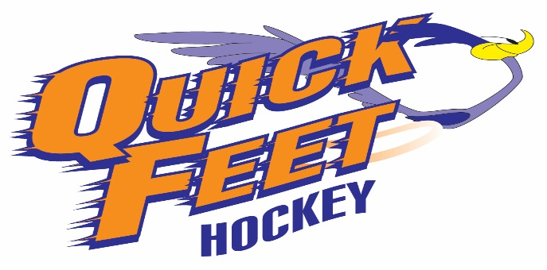
2024 Tryout Registration Form
Player Name:
Address:

Phone#:
Email:
Date of Birth:
Position:
Team Played For 2023/2024:
Tryout Fee = $60.00 (Entitled to first 3 skates & includes HST)
We, the undersigned agree that hockey is a fast paced sport, which can involve risk of serious injury. We agree that we assume all responsibility for the above named player and that we will not hold Quick Feet Hockey or any of its owners, directors, coaches, trainers or other staff responsible for any injury that may occur during the tryout sessions or subsequent practices/tournament game play.

Player Name Player Signature Date

Parent/Guardian Name Parent/Guardian Signature Date

